Our Famous Brownies and Leaders!
We are very lucky to have been asked on several photo shoots. You may have seen our Famous Brownies (and leaders) in the New Brownie Programme and also in Guiding Magazine
All of the girls have now gone on to become guides.

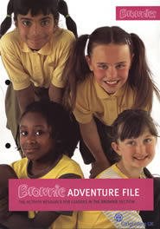

Joanna, Nicola, Caitlin and Cassie Camilla (White Owl) Tanya (Eagle Owl) Dominique (ex brownie - now YL with our Rainbow unit)
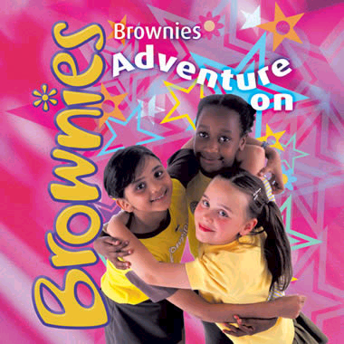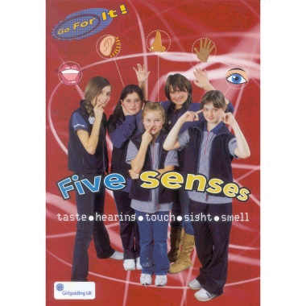

Nicole, Nicola and Dannielle Michaela (2nd from left) & Caitlin (last on right)

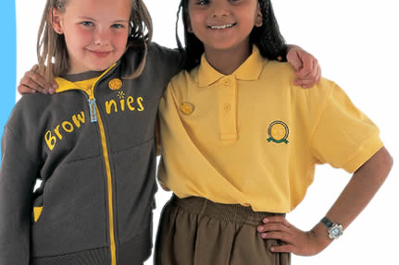
Tamara (Tanya's sister & leader of another unit) Kimberly & Nicole
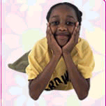

Kimberly, Nicola, Dannielle, Joanna, Hannah Nicola & Hannah Caitlin Dannielle

