A Camping We Will Go!

Kids love camping, even if they've never gone. Just the thought of sleeping in a tent, going on hikes, catching fish, swimming in a lake or riding in a canoe, and gazing at the starry sky while toasting marshmallows around the campfire ... well, it all sounds like fun to them. Lots and lots of fun. And there's so much to learn about, they can hardly wait to get started!
There are dozens of ideas here to be sure your classroom is filled with happy campers. A camping unit can last a week or a month, depending on how much you want to cover. Maybe you're looking for a great way to begin or end the school year, complete with an overnight camp. Or maybe you just want some new songs and poems and a good book or two. Whatever you're looking for, you'll find plenty here to choose from.
So lace up your boots, load up your pack, fill your canteen with cold lemonade, and don't forget your hat and binoculars. It's time to hit the trail!

A-Camping We Will Go
(tune: Farmer in the Dell)
A-camping we will go,
A-camping we will go,
Hi-ho and off we go,
A-camping we will go.
More Verses:
First we pitch our tent
Next we chop some wood
We light the campfire now
We cook our dinner now
We tell fun stories now
It's time to go to sleep
I'm Going Camping!
(tune: Twinkle Twinkle)
I'm going camping, yes sirree!
I'm going camping, won't you come with me?
First we'll pitch our tent on the ground,
Then make a fire as we all gather round.
I'm going camping, yes sirree!
I'm going camping, won't you come with me?
Next we'll cook on the open fire,
Then till stories till we all get tired.
When the stars are twinkling bright,
We'll sleep in our tents 'til the morning light.
I'm going camping, yes sirree!
I'm going camping, won't you come with me?
When we see the morning sun,
We'll wake right up 'cause the day's begun.
There's so much that we can do --
Fishing, swimming, hiking, too.
I'm going camping, yes sirree!
I'm going camping, won't you come with me?



Resource Books to Help You Plan
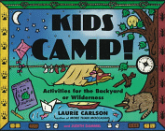
Kids Camp!
Activities for the Backyard or Wilderness
An outstanding resource book filled with
fun and easy activities for your camping unit!
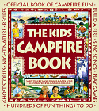
The Kids Campfire Book
Another must-have resource book that covers
camping in detail, with lots of fun and games!
I've used this one at school and with Cub Scouts.
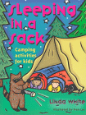
Sleeping in a Sack
Camping Activities for Kids
An introduction to camping, including the types of gear needed,
safety tips, activities, games, songs, and recipes.
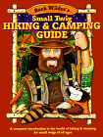

Buck Wilder's Small Twig Hiking and Camping Guide:
A Complete Introduction to the World of Hiking & Camping
for Small Twigs of All Ages
my students loved this book -- great illustrations!
Check out Buck Wilder's Small Fry Fishing Guide, too!

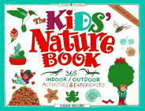
The Kids' Nature Book

365 Indoor/Outdoor Activities & Experiences
You'll use this book all year long!
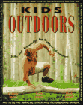
Kids Outdoors
Skills and Knowledge for Outdoor Adventures
Covers the basics of camping, hiking, and more
Under the dark is a star,
Under the star is a tree,
Under the tree is a blanket
and under the blanket is me!
Read Aloud Stories
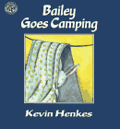
Bailey Goes Camping
Bailey's too young to go camping with his Bunny Scouts
brother and sister, so he has a backyard campout instead
Under $4

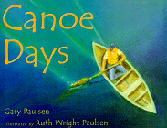
Canoe Days
A gorgeous read-aloud for all ages
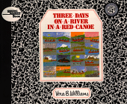
Three Days on a River in a Red Canoe
A little girl describes in her own words and pictures the canoe trip
she took with her cousin and their mothers.
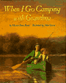
When I Go Camping With Grandma
The Lost Lake
by Allen Say
Early one morning, Luke's father awakens him with exciting news
of a camping trip: they are going to find the Lost Lake, a very special and secret place Luke's father used to visit. Say's watercolor illustrations make this book extra special.
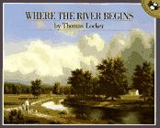
Where The River Begins
Sleep Out
Eager to try out his camping equipment, young Christopher sleeps out alone in the woods for the first time, and almost regrets that he didn't wait for his father to come along. "A deep sensitivity to the world of nature . . . is reflected in the harmony of story and pictures." -- Horn Book Review

Our Hiking Song
(tune: I've Been Working on the Railroad)
I'm a first grade explorer
Exploring every day.
I'm a first grade explorer,
And I have a dream today.
When I'm working or I'm playing
And pretending what I'll be,
I'm a first grade explorer,
Exploring to be me!

Set the Scene
Camping Museum
Children, their parents, you, and even the principal bring in camping items and explain what they're for. Be sure to make time for lots of questions, answers, and shared stories. This is a great time for building connections and drawing on background knowledge. Set the hands-off items up on the counter as a Camping Museum.

Bulletin Board
Make a floor-to-ceiling tree with a river, rocks, and a campfire.

Camping and Hiking Gear to Make
Paper bag vests & paper hats
Binoculars
Cover two tissue rolls with black paper and glue together.
Add yarn to wear around neck.
Star Gazer
Glue a circle of aluminum foil over one end of a tissue roll.
Cover with colored paper, leaving both ends free.
Using a toothpick, punch a few holes in foil end.
Look through the other end and you'll see stars!
How Many Stars Do You See?
Twinkle, twinkle,
One, two, three,
How many stars do I see?
Even in a space so small
I could never count them all.
Five Little Stars
Five little stars, twinkling in the sky.
The first one said, "This is much too high."
The second one said, "I'm the brightest star of all."
The third one said, "Be careful, don't fall."
The fourth one said, "Isn't nighttime fun?"
The fifth one said, "On no! Here comes the sun!"
Then up rose the Sun, so high in the sky,
And the five little stars said "Good bye!"
Reading Corner & Creative Play
Set up a tent with sleeping bags, pillows, and flashlights.
Make extra tents the old-fashioned way ... put a blanket over chairs or a table.
Bring in an inflatable boat with oars, life jackets, fishing vests, hats, fishing poles and tackle boxes. Don't forget a bucket to hold the fish!
Items for Creative Play
picnic basket w/ plates & utensils
camp stove
mess kits
maps
compass
binoculars
kaleidoscope
camping books from Auto Club
canteens
lantern
flashlights
cub scout handbooks
backpacks
small sleeping bags
camp fire built of logs tied or glued together
Stories for the Reading Corner
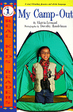  My Camp-Out  Great Photography!  Under $4 | 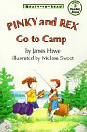  Pinky and Rex Go to Camp  Ready to Read Level 3  Under $4 | 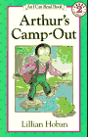  Arthur's Camp Out  I Can Read Book, Level 2  Under $4
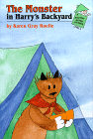  The Monster in Harry's Backyard  A raccoon sneaks into a backyard campout | 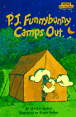  P. J. Funnybunny  Camps Out  A Step Into Reading Book, Step 1  Under $4 | 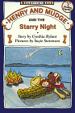  Henry and Mudge  and the Starry Night  Under $4
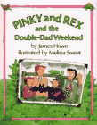  Pinky and Rex and the  Double Dad Weekend | 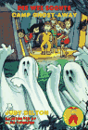  The Pee Wee Scouts  Camp Ghost Away  Under $4 | 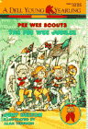  The Pee Wee Jubilee  Everyone loves the Pee Wee Scouts!  Under $4
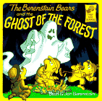  The Berenstain Bears and the  Ghost of the Forest  Under $3 | 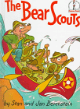  The Bear Scouts  In rollicking rhyme, Papa Bear shows the cubs  the ins and outs of camping | 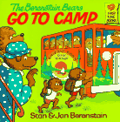  Berenstain Bears  Go To Camp  Under $3
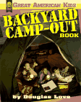  Great American Kids  Backyard Campout Book  Under $6 | 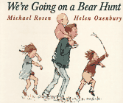  We're Going on a Bear Hunt | 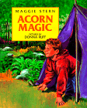  Acorn Magic  A boy's first camping trip
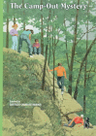  Boxcar Children  The Campout Mystery  Under $4 | 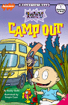  The Rugrats Camp Out  Under $4 | 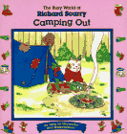  Camping Out  Under $3
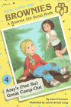  Amy's (Not So) Great Camp Out  Under $5 | 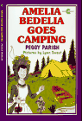  Amelia Bedelia Goes Camping  Under $4 | 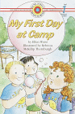  My First Day at Camp  Bank Street Ready to Read Series  Under $4
Camping Math
Friendship Trail Mix
Use peanuts, chocolate chips, Fruit Loops cereal,
mini marshmallows, raisins, M&M's or Skittles.
Younger children count out 10 of each item.
Older kids measure a scoop of each, then graph their results before eating.
Compare and contrast graphs -- did everyone end up with the same number of raisins?
Discuss why or why not. Make group graphs, or a whole class graph.
Camping Trail Mix Store
Using the same materials as above, set the items out in a center to be used as a store. Give children 25 cents in assorted coins, and they get to shop. Everyone helps make price signs and set up displays. Kids will take turns being the shopkeeper and making change. Older kids can write a purchase list before they buy.

Have You Ever Been Camping?
Yes | No
Give each child a 3 x 4 blackline picture of a tent to color and write their name on. You could also graph whether they slept under the stars, in a tent, or in a trailer or RV.
Let each of the children who've been camping tell a short story about their camping trip, and allow the other children to ask questions.

Other Graphing Ideas
Make a camping graph book from any camping question, or collect all your graphs into one book!
What's your favorite forest animal?
Have you ever been in a boat?
Which do you like better, hamburgers or hotdogs?
Have you ever seen the Big Dipper?
Have you ever gone fishing?
Have you ever gone on a hike?
Do you like picnics?
What color is your backpack?
Would you rather go camping with Arthur or Little Critter?
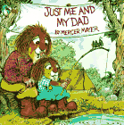  Just Me and My Dad  Little Critter and his dad  go camping  Under $3 | 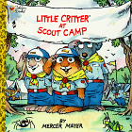  Little Critter at Scout Camp  Under $3 | 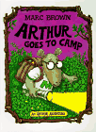  Arthur Goes to Camp  Under $5  Also available as a book  and tape set
Camping Picture Lotto
Make a lotto card with one-and-a-half-inch squares on it.
Use a 3x3 grid for younger children, a 5x5 grid for older kids.
Make a master sheet with the same size squares, but at least 5 more than on the bingo card. Using clip art, paste camping pictures in all the squares on the master grid. Pass these out and the children choose which pictures to paste in their bingo squares. When their cards are ready, play like Bingo.
Camping Story Problems
Have children write and illustrate word problems,
then make into a class book.
Camp Supply Sorting
(sorting, classifying, categorizing)
Collect a large assortment of camping supplies.
Children will sort them into categories and then draw or write about them.
Squirrel Nut Hunt & Sorting Activity
Hide nuts inside or outside, like you would for an Easter Egg Hunt.
Younger children sort theirs by type ... walnut, peanut, pecan, etc.
Older children sort theirs, and they get points for each type of nut.
This is a good team activity, pairing older and younger students.
Patterns
Children can make patterns from many materials ... leaves, rocks, nuts,
teddy bear counters, water bottles, backpacks, etc.
For small objects, they can glue their pattern to a piece of paper and label the type of pattern (i.e., ABAB or AABCAABC). For larger objects, they can build their patters on the table or floor, then draw their patterns on construction paper, write about them, and assemble them into a class book.
Count on Ants
Camping means warm weather and picnics, and picnics mean ants!
(numeral recognition, counting, one-to-one correspondence)
Glue magazine and newspaper pictures of food to twenty paper plates, then label the plates with a large number in the center, from 1 to 20.
Put the plates in a picnic basket, along with a box or baggie full of plastic ants. Children choose a plate at random, read the number, and put the ants on the plate so they can eat the food! This is a great Language Experience activity for younger children ... you could even let them cut and paste the pictures to their own plates, glue on the the ants, and then dictate a story to you. Mount the stories and paper plates on red-and-white checked paper place mats (or weave your own) and hang them on the wall.
Forest Animal Songs & Poems
Along the Trail
(tune: Skip to My Lou)
I met a bear along the trail,
I met a bear along the trail,
I met a bear along the trail,
I stood very still.
Additional verses ~ squirrel, deer, rabbit, skunk.
Raccoon
Raccoon sleeps in a hollow tree
While the sun shines on you and me.
Sleep, raccoon.
Sleep, raccoon,
Warm and cozily.
In the darkest part of night
Raccoon has the best eyesight.
Look raccoon,
Look, raccoon,
My, your eyes are bright.
Raccoon hardly makes a sound
When he prowls all around.
Hunt raccoon,
Hunt raccoon,
Find food on the ground.
Mr. Squirrel
Oh Mr. Squirrel,
Way up in the tree.
I see you,
Do you see me?
Oh Mr. Squirrel
Collecting nuts in Fall,
How will you remember
Where you hid them all?

Campout Cooking
Smores
Put a marshmallow and a Hershey kiss on a graham cracker
and melt it in a toaster oven.
Ants On A Log
Spread peanut butter or softened cream cheese
on celery sticks, and put raisins on top.
Popcorn
Measure it before and after it's popped, and have the kids guess
how much it will make. Graph predictions and results.
Happy Camper Fruit Salad
Everyone brings a piece of fruit to share.
Talk about fractions as you cut the fruit up.
Mix with orange juice or pineapple juice and serve.
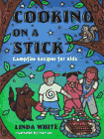
Cooking on a Stick
Camping Recipes for Kids
My Picnic Basket
(tune: A Tisket, A Tasket)
A Tisket, A Tasket,
A special picnic basket.
I made it strong, it wont be long
'Til I begin to pack it.
To pack it, to pack it,
I cannot wait to pack it.
Crackers, fruit, and sandwich, please,
To put inside my basket.
My basket, my basket,
My special picnic basket.
I'll fill it up with such good food!
I'm glad I made my basket.
Activity
Have kids make their own picnic baskets by weaving construction paper and folding the edges up to staple. Or get a Chinese restaurant to donate containers with handles for your students to decorate and pack their lunch in, for your hike across the playground or into the woods.
Language Arts Activities
Brown Bear Innovations
Start with my ideas or make up your own
Camper, Camper what do you see?
I see a forest peaceful as can be.
Forest Forest what do you see?
I see a squirrel living in a tree.
... a blue jay noisy as can be.
... a river flowing out to sea.
... fisherman standing next to me.
... a rainbow trout swimming close to me.

Who lives in the forest?
A _____ lives in the forest.
Use as a pocket chart activity to teach tracking and matching,
then make a Class Big Book.
Have word cards and pictures available to put in the blank.
Repeat the sentence in your pocket chart as many times as you like.

Backpack, Backpack,
What's In My Backpack?
Make a class Lift-the-Flap book.
Each child gets a page with a 4 x 5 box in the middle,
and these words at the top:
Backpack, backpack
what's in my backpack?
Something that's _________.
Students draw a picture in the box,
and glue a picture of a backpack over it.
Below the picture (and inside the box) it says
It's a _______.

A Camping We Will Go Class Book
After you've explored the many facets of camping, brainstorm a list of possible destinations and ask your students where they'd like to go on their own camping trip. Would they like to camp in the forest or in the desert? At the beach or by a river or lake? At Grandma's cabin on top of a mountain, or at home in their own backyard? Show children how to cut a tent from a 6x6 square of paper, and how to make a lift-the-flap door. They can draw a picture of where they'd like to camp, add the tent, and glue a picture of themselves inside. Make into a Big Book.

Science & Art Activities
Leaf and bark rubbings
Rock collections
Mystery hike -- follow clues or a mystery map
Sock walk -- walk outside in just your socks,
then shake the seeds out and see what grows!
Collect sticks, seeds, leaves, nuts, pine cones, etc.,
and glue them together to form bugs and animals.
Make Nature Wreaths by gluing found objects to a tagboard circle with a hole in the middle. Add fancy touches like glitter, stars, and gold ribbon.

Don't Forget Smokey the Bear!
A great way to spice up your camping unit is to call the nearest office of the National Forest Service, and see what Smokey the Bear is up to in your neck of the woods. You might be able to arrange for Smokey to visit your classroom, along with a Ranger friend from a state or national park. And you can probably get the ranger who answers the phone to send you some fun freebies for your class: Smokey the Bear posters, buttons, bumper stickers, or coloring books. Be sure to ask.

Smokey's Rules For Preventing Forest Fires
Never leave a campfire unattended.
If you see matches, give them to an adult immediately.
Always keep a bucket of water and shovel near a campfire!

The Bear Facts
There are several versions of the "true" story of Smokey the Bear. Growing up in California, I was told that Smokey the Bear was a real bear that was injured in a forest fire in California. He was badly burned on his face and his body, and it took a special team of doctors and caregivers to save his life. After he recovered, Smokey lived at California's Folsom Zoo until he died in 1985. His mate, Alice, and his son Ensign are still at the zoo. Many teachers in California still tell this version of the story.
Other sources say Smokey came from New Mexico. According to this version of the story, in the 1950s a bear cub in the Capitan Mountains of New Mexico got caught in a forest fire. To escape the flames and burning bushes, he climbed up a tree. By the time the fire fighters found the scared and hungry cub, the forest was charred and blackened.
The firefighters, park forest rangers and the warden were so moved by the spunky survival of this little cub that they named him Smokey. They put him on a plane and sent him to the National Zoo in Washington, D.C. to live.
In the town of Capitan, New Mexico, people erected a park and museum to honor the brave bear. The museum still exists today, and the park says Smokey is buried there. Visit their website at Smokey Bear State Historical Park - New Mexico.

Smokey the Bear Links
SmokeyBear.com
forest fun, interactive mazes, coloring pages,
bear facts, and Smokey mail
Smokey's Coloring Book
print out a coloring book to reproduce for your class
good fire safety rules and a quiz are include
Smokey's Activity Sheets
10 fun sheets to print out from California's Stanislaus National Forest Service website. You'll find more great stuff in their kid center, too, including information on forest management and a coloring and activity book called Tread Lightly that you can print and reproduce. The TREAD Lightly program uses the letters in the word TREAD to convey this message ...

U.S.D.A. Forest Service Pacific Southwest Region
Map of all of California's National Forests
plus a Virtual Visitor Center
Timber Trek
a kid's site run by the Woodrow family bush camp and
Australia's National Association of Forest Industries
Be sure to visit their library for craft projects,
recipes, activities, and puzzles, and read the latest
issue of their online kid's magazine, too!
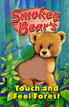
Smokey Bear's Touch and Feel Forest
Themes Related To Camping
Forest Animals | Bears
Picnics | Fishing
Ants  Visit my Ants page! | Insects  Visit Going Buggy!

Looking for more ideas?
My bookstore pages have lots of information on how I use various materials in my classroom, and on activities you can do with your students. The thematic pages are complete unit resources, with lots of poems, songs, and links on each page. Make yourself comfortable and take a look around!

