HARMONY EXPRESS-ION

Volume 4, No. 3 March 2002

FOLSOM HARMONY EXPRESS WATERSHED

After many a season, the Folsom Chapter has changed its address. While we had talked about the possibility for the last couple of years, when we finally made the move it was with dramatic suddenness. Bert Weichenthal is to be thanked for getting us together with Redeemer Covenant Church, our new host. But thank Stan Trumbull and Charlie Clark too, while you’re at it, for they did the actual negotiating.

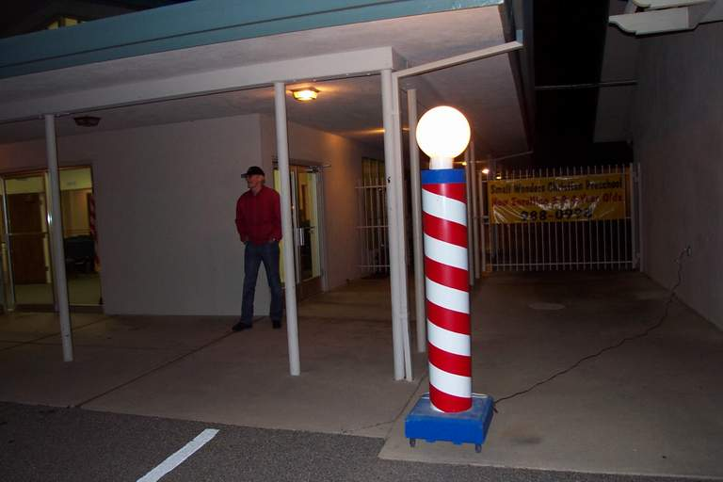

Here’s Burt Weichenthal, like Lili Marlene, waiting to guide the uninitiated to the inner sanctum.

Additional pictures of our new home can be found in March Supplement 1.

And then a second barberpole just in front of Swenson Hall, the inner sanctum

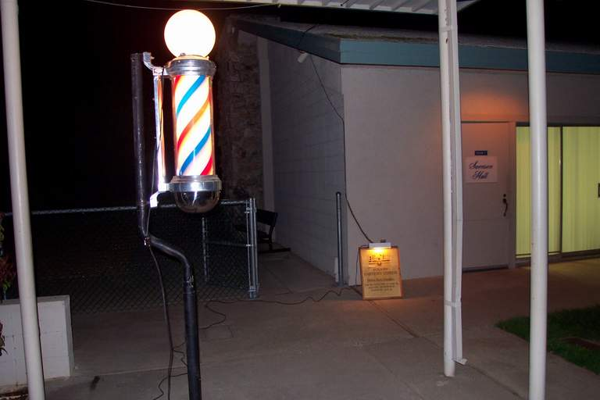

Once inside you see something like this:

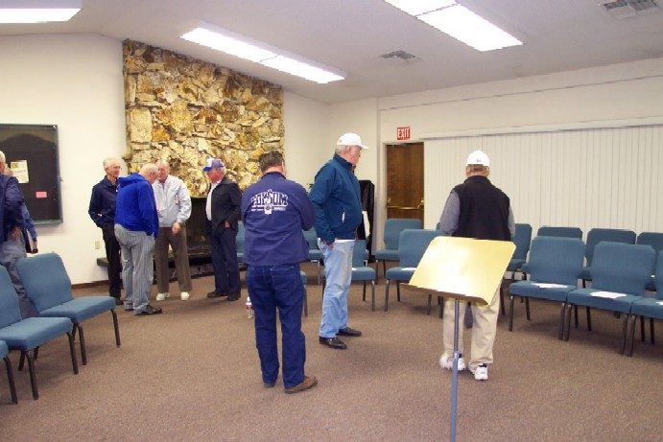

Hopefully we’ll be able to get used to the quality and roominess. Who knows, we may even want to start inviting guests to enjoy the facility with us.


GONE BY THE BOARD …

President Charlie Clark opened the meeting at 7:27 PM on 7 March with board members Stan Trumbull, Marion Gribskov, Hersh Roby, Burt Weichenthal and Bill Seibel present. Phil Taylor attended as well. (The meeting got underway later than usual to accommodate the prez who had to finish a class he is currently attending.)

As always, you should consult Hersh Roby’s official minutes if you really want to know what went on. I tend to call ‘em as I see ‘em, and I’m very myopic. And as my wife and Ken Potter can tell you, my hearing is very selective too.

This particular meeting my attention was seized by our Secretary/Treasurer’s outstanding financial presentation. Hersh Roby put on a dog and pony show the like of which I have not seen since my pre-retirement bureaucrat years. He had charts and graphs and projections and good advice in copious quantity. It was easy to see why the chapter has remained solvent under circumstances I had thought financially catastrophic. The downside of his excellent presentation was that it made all too clear the need for a chapter dues increase if we are to continue to avoid bankruptcy.

And this, of course, brought the board to the cusp of the meeting, namely formally executing the chapter’s wish to relocate, and instituting the dues increase the move will require. Beyond this, it is of note that the board approved Stan Trumbull’s proposal to schedule “Quartet Knights” for 16 May. A regional approach to encouraging quartet formation, you can expect to be hearing much more about this program over the next few weeks.

The board meeting concluded at 7:55 PM.

The Folsom Chapter of the Barbershop Harmony Society [SPEBSQSA, Inc.] meets at Redeemer Covenant Church, 6800 Main Avenue, Orangevale every Thursday at 8:00 PM. Guests are warmly welcomed and set to singing immediately.

President: Charlie Clark
Vice Pres. Membership: Stan Trumbull
Vice Pres. Music/Program: Marion Gribskov
Secretary/Treasurer: Hersh Roby
Immediate Past President: Paul Bennetts
Board Members at Large:
Burt Weichenthal
Bill Seibel
Director: Jim Campbell
e-Ditor: Bill Seibel

CHAPTER CHATTER

March may come in like a lyin’, but trust me, the eDitor doesn’t. In fact, one might have thought it early April since guests showered upon Stan (ever-hopeful) Trumbull at the first meeting of the month on the 7th. Returning were Steve Taylor and Mike Aita. Returning after a much longer absence was Ron Beam. Ron was a charter member of the Folsom Chapter. He’s just moved back to this area from Oregon and we hope to continue to see him among that sturdy phalanx of basses supporting our chorus.

Though several regulars weren’t present (on their way to the FWD spring prelims in Fresno), the meeting was nonetheless well attended. El wavo was in another drill mood, so considerable time was spent whipping Lida Rose into shape (and please don’t get any kinky ideas about this. Our director simply expects us to observe speeds and pitches posted in the music). He also spent similar time on a couple of other repertoire numbers we’re likely to be using for the April show. Not to mention our bugaboo, No One’s Perfect. Jim wanted to be sure that when this number is performed for Les Cudworth’s congregation in April, the dissonances are those intended, not those we pioneered.

Despite the drill, there was plenty of quartetting, but then that isn’t really news, is it? News is what prez Charlie Clark delivered during the business session. He announced that henceforth the chapter had a new home, the Redeemer Covenant Church. Having delivered the good news with great gusto, he quietly allowed as how the board found it necessary to raise chapter dues by 10 dollars to help pay the rent for the new meeting place. Not a word of protest was heard. For such a big-voiced guy, Charlie can be pretty quiet at times, so some of you may have missed his postscript announcement. Euphoria will do that to you too.

Those new digs proved mighty impressive when we got to them for the 14 March meeting (and just in case you don’t read the front of this rag, check it out for a couple of pictures taken at our new location). Whether curiosity or otherwise, the turnout was splendid, despite the absence of stalwarts like Stan Trumbull, Hersh Roby, Ken Potter and a few others. As if to accommodate the absences, we saw a few we don’t ordinarily see, such as Dusty Rhoads, Bob Mehl and Nick Sadowy. Mike Aita made a guest appearance too. Redeemer Covenant Church choir director Glenn stopped by briefly also after his choir rehearsal. Not sure whether his parting comment was “awesome” or “awful” but he did seem impressed one way or the other.

Chapter program that night was devoted to potential show songs for our April whoopdedoo upcoming. Marion (despite all, still the agrarian) Gribskov provided a program full of possibilites which el wavo explored with us. Some, of course, weren’t able to help out because of colds, specifically our prez, Charlie Clark. Did anyone but me detect an improved sound from the lead section? While we didn’t make it all the way through the entire list, enough were successfully negotiated to suggest we’ll have enough material to fill the chorus portion of the show.

A word about the afterglows: only eight attended the one following this meeting, the smallest group yet at Don Pancho’s. However, smaller attendance was occasioned more by health conditions than lack of interest. Fact is this location, while not up to the spoiling we got at Daniel’s, is working out quite well. Poor Adam, one of the managers, is working himself into a lather for us, and I hope each time we attend an afterglow we’ll toss a buck or two into a basket by way of thank you. Without Charlie there to remind us on this night, we forgot to leave a small monetary thank you.

Quite unlike the usual Harmony Express meeting, that of 21 March had a somber cast. The entire membership was aware that el wavo, Jim Campbell had suffered a stroke the morning of St. Patrick’s Day. By meeting time we knew that all medical signs reported from the hospital were encouraging, but we are a small, close-knit and caring group, and wanted to see him back in front, complaining about our singing.

However, we were fortunate enough to have Kent Borrowdale step into the gap as he has done a number of times in the past. He intends to fill in as long as need be, and began immediately to rehearse numbers for our upcoming show. And if necessary, he informed us, he’d direct during our show too. We have had reason in the past to be indebted to this talented fellow, and now we’re going to wind up owing him even more.

While attendance was a bit sparse, with all manner of regulars somewhere else, Stan Trumbull would have been delighted with the number of guests. Steve Taylor came by again for immersion in the Folsom experience, as did Ramzi. A third guest was an ex-member name of Munson Hinman who we hope will come back again and again. Munson, like Ben Loftsgaard is one of those pioneer barbershoppers from over a half century ago who has too much to offer to remain tucked away in musical retirement.

The big news at the final meeting of the month on the 28th was director Jim Campbell’s reappearance. He stepped in to a standing ovation about 9 o’clock. Kent Borrowdale led the chorus in a rousing rendition of For He’s a Jolly Good Fellow, while Miz Dixie beamed (she was Jim’s designated driver that night). What is more, both Jim and Dixie joined us for the afterglow at Don Pancho’s.

But wait, that ain’t all! We had other guests galore. Bob Hunter of the Davis/Woodland/Vacaville Chapter came to our meeting with Kent. Bob Horvath came back down the hill from Truckee, while Steve Taylor drove in from the wilds near Lodi. These two are looking to form a quartet and have found that the Folsom Harmony Express provides a good quartet fix while they’re looking. We also had the unexpected pleasure of a visit by ex-member George McCay. George has been doing a fine job as sunshine man for the Far West District, and decided to put a little sun in his own life by visiting us. (According to him, though, he just wanted to check out our new digs.) Picture if you will the euphoria all these guests brought to the heart of Stan Trumbull, because superlatives fail me.

And finally, recognition time. Hersh Roby stepped forward during the business meeting to present membership cards to two chapter regulars. To Johnny Desmond he handed a re-up card with 8 hash marks, while baritone extraordinaire Ken Potter got one with 46. I think both would agree that it’s been time well spent …

Articles without a byline or other credit are by the eDitor, and do not necessarily reflect the views of the Society, the District, the Folsom Chapter, its membership, or even the eDitor himself. To be sure, contributions are welcome, but only the truly outrageous will be published.

BLISS ‘N’ BLATT

The times they be a changin’ … Barbershopping is better than ever but just keeps shrinking. What on earth accounts for such an alarming situation?

An all too brief discussion on the FWD listserve late in February brought a rare cognition to the hand-wringing that’s been going on in the Society for the past few years. It essentially began with a lament by Steve Sammonds, Peninsulaires Chorus Director, regarding the sparse signup for the small chorus contest being held in Fresno in March in conjunction with the International Chorus Prelims. Only three choruses chose to compete.

One of the grand old men of FWD barbershopping, Don Gubbins responded with a thoughtful message in which he opined that the disappearance of division vice presidents accounted for some of the loss of interest in the contest, since they are no longer available to encourage chapters to participate in division and district events. He went on to observe that not just shrinking membership, but shrinking convention/contest attendance begs for attention.

Jim Larkin, IPP, Rancho Bernardo Chapter chimed in to sketch a stark outline of the situation confronting most small chapters these days. He stated: “With an average age of over 65 for our active members (15-20), we have chosen to concentrate our efforts on increasing membership, doing things with our fellow chapters, and serving the community we live in rather than compete as a chorus.” He noted that perhaps someday his chapter will be able to return to the competition arena, but that it was out of the question for now.

David Germain, President of the Sierra Vista Chapter (AZ), another small chapter, expressed a very similar view. However, he added corroborative detail which spelled out clearly the difficulties facing most small chapters.

There were quite a few other voices in this discussion, all with well-considered commentary. Some offered very good suggestions, but however good, I regard them as palliatives. Instead of treating symptoms as we have been doing, we must recognize that we are going to have to treat the disease.

Dyed-in-the-wool barbershoppers have a hard time confronting the reality of our situation. Being as embued with the spirit as they are, they cannot conceive of a barbershopper who is not equally motivated. The facts, however, suggest that David Germain’s words about Joe Barbershopper are right on the mark: “We are increasing our participation where we can, but it’s hard to get lethargic members to do anything beyond show up on Tuesday nights and do local sing-outs.”

Our Society pretty well meets historian Oswald Spengler’s definition of rigidity. He postulated that nations, like organisms, have a clear life cycle, being born, maturing and then gradually becoming inflexible until they finally topple. Some years ago John Gardner pointed out that organizations too have a life cycle, and he urged that they adopt a program of “self renewal” in order to postpone indefinitely that ultimate rigidity which ends an organization.

And if you have some difficulty grasping this concept, just recall how simple SPEBSQSA was when O.C. Cash and Rupert Hall brought it to life. Then think about the successive iterations across the years that raised competition to its present excellence, that evolved into a successful music education program quite unlike any other, that spawned all manner of subsidiary organizations (from associations of champion quartets to woodshedders, scribblers, song arrangers, public relations specialists, etc.), that created a huge volunteer bureaucracy across the nation, that codified the entire structure in endless volumes of rules, regulations and customs. Much as we miss them, it is probably just as well that Cash and Hall are no longer available to revise and update their derisive coinage of the acronym SPEBSQSA.

I do not hold our leadership responsible for the straits we are in. I think our leaders should stop beating themselves to death, for they and we are the victims of demographics and changed mores. Instead, all of us need to step back, take a good look at our situation, and then set about redesigning our Society for contemporary conditions.

Back in O.C. Cash’s day just about everybody gathered around the piano and sang during family or other get-togethers. They sang songs they had learned in school as kids, as well as the popular songs of the day. Because there weren’t a lot of places available that provided entertainment, people amused one another as well as themselves. Times were mighty tough too. There wasn’t a lot of spare change to spend for what entertainment existed. Moreover, people then were quite insular. They stuck pretty much to their own racial groups and social strata. Customs were accordingly fairly rigid. It was a time and place and people only too ready for the outbreak of barbershop harmony.

Fast forward to our own day. Almost all the sources of music education have dried up in America. Not many schools field any kind of instrumental ensemble, fewer still vocal groups. Amusement, recreation, entertainment, diversion – you name it, it exists in a bewildering array of choices, and there is now plenty of opportunity and discretionary income to indulge ourselves. America, if you will, has gotten rather fat, dumb and happy, a nation of spectators, not participants.

Professionals entertain us now, whether in the society at large or our own beloved barbershopping Society. What began as a Society of amateurs has become a two-tiered organization, a narrow band of professionals and a very broad band of amateurs. Aging amateurs, I must add, for this group is fading away, thereby jeopardizing the vitality of the entire organization. Thanks to the foresight that led to the Young Men In Harmony program, I don’t foresee the death or our organization, just a long dry spell before the new cadres come on-line.

But all of that having been said, I have no clear agendum to lay before you, no road map to a brave new world. All I can offer is the caution that we not throw out the baby with the bathwater during a process of self-renewal. Our accomplishments as a Society strike me as nothing short of amazing. We don’t want to sacrifice one bit of our urge for musical excellence, for by it we have contributed immensely to our nation’s cultural treasury. However, we may have to swallow hard and temper it somewhat to accommodate Joe Barbershopper’s singing needs.

While I don’t have a road map, there are a number of questions we might pose to one another. In the process of discussing their answers, we may find a few sign posts which could point the way. What follows is not meant as an exhaustive list, simply some thoughts to ponder:

Do we really need all the organization we’ve built up, complete with trendy mission statements and carefully structured objectives? Do we really require all the layers we now have between International Headquarters and the chapters of grunts? Do we really have to have all those missionaries out inspiring the chapters to conform to some preconceived pattern? Might there be some value to encouraging chapters to experiment with operations, much as the Federal government looks to states to lay out new paths?

Is competition really for everybody? And if so, in its present form? What about the judges? Is there any danger of them becoming a priesthood imposing a stifling orthodoxy? Is it possible that their professionalism may contribute to Joe Barbershopper’s disinclination to compete? In pursuit of cost containment, do we really need such large panels of judges? Might it not be possible to train judges for total presentation rather than subjectively defined pieces? Can competitions be more flexibly structured instead of rigidly run through division and district levels prior to international? And why do we even need a separate district champion competion at all since the winner of the District international prelims would serve nicely? Is there any mileage to intra- and inter-chapter competitions in limited geographic areas, perhaps qualifying some in local surroundings for competition at district level?

Can we accommodate a viable two-tier system, and if so, how can it be made to work? Since competition motivated singers have already voted on this question with their feet, and formed chapters for that purpose, can we or should we try to reverse the phenomenon? What’s to be done about those remaining behind in the hinterlands, the scores of small chapters struggling to stay afloat? Should we think about setting up some sort of “farm” system, requiring big, successful first tier chapters to assume responsibility for a surrounding geographical area of chapters, helping them by direct, regular participation in their operations without also automatically draining them of their best singers? Since those remaining in the hinterlands are disinclined to compete at present, is it possible they might be interested in a competition founded upon scores for “most improved” rather than absolute best?

Is there any workable alternative to meeting Society financial needs through heavy reliance on contest and convention income? If not, can those gatherings be restructured to make them more “local” without sacrificing the economics of scale? Might chapters be persuaded to make regular voluntary gifts for Society operation as they now do for worthy causes? Should any thought be given to “taxing” chapter shows and performances, and if so, at what rate? And if so, can the Society provide a popular quid pro quo by bringing events dear to the heart of Joe Barbershopper close to home? Should we look into some sort of cooperative arrangement with other a cappella groups, seeking to share expenses at joint events? Can we find partners otherwise for such things as musical education and acquisition of printed music, similar, perhaps to bulk buying of pharmaceuticals by governments and HMOs?

What obligation, if any, do members have to give something back to barbershopping, thereby enhancing the functioning and durability of the Society? Should those presently giving back at higher organizational levels in the Society be obliged to also actively participate in their local chapters? Conversely, are some of those now giving, going to extremes hazardous to their health or well-being? Should all instead of just the few top-tier quartets now doing so voluntarily be required to take an active role in the affairs of their chapters of origin? Can such quartets not only entertain Joe Barbershopper, but also bring him to understand that the forest would be a very quiet place if only birds with lovely voices were permitted to sing?

Has the evolution of the chorus director, who originated as just a teacher of songs to groups of men interested in forming quartets, achieved maturation? Do we have a two-tiered system of chorus direction to match the de facto existence of two-tiered membership? To what extent if any has directorial ego (absolutely essential to improved chorus performance, by the way …) compromised normal chapter life? Have the leading specialists, the voice and performance coaches, arrangers and song writers gravitated to those able to afford them? Could Joe Barbershopper even comprehend their wares if he could afford them?

None of the questions I have posed are the “right” ones, and I regret that their phrasing will gravely offend many in our Society. However, if not these questions, then some like them must be addressed in a systematic, orderly fashion. I am aware that the Society’s long-range planning committees have probably examined all of the questions posed above as well as many more. However, up to now I believe the prevailing state of mind has been more “how to fix it” than “how to redesign it for our times”.

I think we need to bite the bullet and get on with that task.



4 April – Board Meeting, Redeemer Covenant Church, 7:00 PM

4, 11, 18, 25 April – Folsom Chapter Meetings, Redeemer Covenant Church (6800 Main Avenue), 8:00 PM

18 April – Harmony for Lunch Bunch Meeting, Hof Brau Plaza, 11: 30 AM

20 April – Folsom Invitational Show, Citrus Heights Community Center, 8:00 PM

21 April – First Baptist Church Banquet Performance, VFW Post, 3300 U Street, North Highlands, 1:00 PM

25 April – Fountainwood Residential Care Performance, 8773 Oak Avenue, Orangevale, 7:30 PM

16 May – Quartet Knights, Special Chapter Event

27 July – Sacramento Chapter Quartet Workshop

Niche market success

El Bambooze, California

Barbershop News Service

Considerable success has attended a start-up company in this small southern California town. Following many months of extensive research into customer problems with various products, local entrepreneurs settled upon an obscure problem, but one with a growing customer base.

Harshbreath Pipes manufactures very unusual pitchpipes in that the normal range of pitches – F to F or C to C , for example – are not built into the product. Instead, each pitchpipe is for one tone only. The instruments look exactly like the standard product, but instead of 13 different pitches, these produce the same tone in each of the 13 holes.

“We don’t know why some chorus and choir directors have the problem,” Horst Geldimtasche, company president stated, “only that many seem to destroy certain specific pitches.” He went on to explain that it is thought to be a psychokinetic manifestation.

“Some directors have particular problems with, let us us say, Ab pitches,” he stated. “These are perfectionists who direct their perfection outward, that is, they expect singers to be perfect. On the other hand, there are insecure directors whose pitchpipes cannot long maintain a C.”

Geldimtasche cited research suggesting directors’ temperments vary widely, and causal effects associated with specific behavior have been statistically validated. “Of course,” he added, “traditional pitchpipe manufacturers also have a demonstrable quality control problem in the manufacturing process.”

© 2002 William Seibel

