Board of Trustees

Heather Richards: Principal

Robyn van der Sande: Chairperson

David Allan: Treasurer

Tracy Hale: Secretary

Kevin de Jong: Property

Derek Wiseman: Property

Lynne Sladen:
Teacher Trustee

Welcome to all new families to Glamorgan who have started this term. The Glamorgan Goss is a newsletter that comes out once a term from the Board of Trustees to let our community know what we have been doing for our school. Please feel free to collect a copy of last terms newsletter, which introduced your Board, and to some extent explains our role in the school.

I know that as parents a large part of our understanding of the curriculum taught in specific areas is greatly enhanced by open invitations with afternoons/evenings to view our children’s work. This was certainly achieved with the children’s demonstrations in our new Discovery Centre and the recently held visual arts festival, both well attended by parents. Hopefully you all took the opportunity to read the information flyer on the arts curriculum that came home just prior to the arts display. Thank you to Heather Richards, all staff and of course the children for their efforts this term.

It has indeed been a busy term and we must continue to thank all parents that have assisted the school whether it has been in the classroom, school trips, sports coaching or fundraising events. A lot of what happens at school for our children is not possible without your support.

I recently read an interesting article that highlighted the link between community and school and the board’s unique role in this. It said ‘Good governance practices says that boards should be immersed in satisfying their owners. Few would question that whilst the taxpayer is the major shareholder in schools, the real ‘moral’ owners of any school are its parent community’.

Thank you to those of you that responded to our Annual Community Survey. Congratulations to the McGlone family who were our lucky draw winners and have received a $100 dinning voucher at Valentines. As I have previously mentioned in the Goss we believe that communication is essential in our children’s education. It was disappointing to have had just 100 families from the 448 in our school community (only 22% of you) take the opportunity to communicate to us your concerns, queries, comments on how we could improve and enhance your children’s environment and education. Once we have had an opportunity to study the results and comments this survey will be discussed in depth at an upcoming Board meeting and will assist us greatly in guiding us on areas that you have concerns and suggestions on. I must say that I am pleased to report that we are already ‘onto’ some of the areas of concern in enhancing the school environment that you have highlighted!
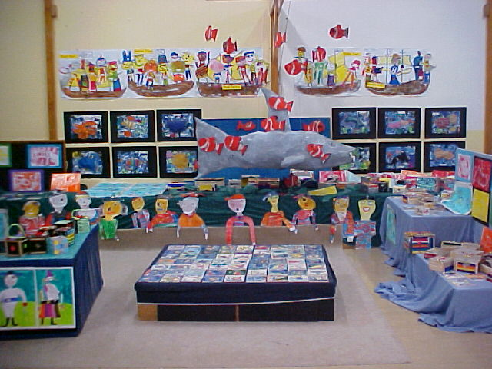
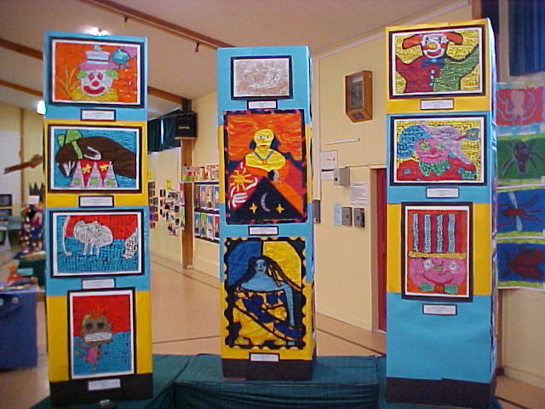

Some of the children’s terrific artwork at the recent Arts Festival

Thank you to our ‘Friends of the School’ team for their wonderful fundraising efforts this term. Your support with these fundraisers has provided additional books to the value of $2,447.00 for our wonderful Library and the children’s effort in the Library Athon has raised around $8,000, which will assist greatly with the field upgrade. It is wonderful to see the children benefiting from these fundraising results.

Property

Painting – The painting of our school will continue over the holiday period and throughout next term. Much needed roof repairs and roof painting will further enhance the visual aspects of our environment.

Administration Block – Some anticipated plaster and paint finishing will happen in our new administration block over the holidays. On its completion we will finally be able to put up our eagerly awaited school notice board in the reception area and start to adorn our walls with some of the beautiful artwork our children produce.

Field Drainage – The Board has approved the field drainage and sand slitting which is due to commence next term, weather permitting. This work will improve the availability of our field after inclement weather. Unfortunately it will mean that our field will be out of action for some time but the end results for the children will be worth the inconvenience.

Work is presently being carried out to enclose the base of the Library, Technology and Discovery Centre.
Other work due to commence shortly will be the long awaited completion of our road frontage, the installation of a new outside community notice board and school signs. There will also be some additional concrete pathways established.

Resource Room – We are hoping to commence work next term on establishing a much-needed central resource area for staff in the old library (opposite Room 7). At present resources are scattered throughout the school and it has long been a dream to have these valuable teaching resources better utilised by centralising them and enabling teachers quick and easy access to them. We are extremely grateful to and would like to thank Fiona de L’Isle, a parent of two children at our school, who has kindly drawn up plans for remodelling the old library and these are ready for Council approval. We are presently seeking a builder to quote on this renovation work so if you have any contacts that may be interested in this job, please let Heather Richards know.

Landscaping – We are also keen to undertake much needed planting at the front entrance to the school. Many of you commented on the grounds in our community survey and we are pleased to be able to say that this has already been discussed. We do feel that a much wider view is required and that a lot of landscaping work needs to be addressed to enhance the school environment. We are interested in hearing from any parents involved in landscape design or if you have any contacts that would be interested in looking at areas in the school that require development and improvement. Please contact Heather Richards.

Vandalism – Unfortunately with the school holidays also comes some mindless vandalism and graffiti for schools. If you are visiting the school grounds to utilise the playgrounds etc over the holidays we would be grateful if you could keep an eye out for any suspicious behaviour or damage and phone the police.

The year is disappearing very quickly and it is hard to believe that Term 4 is just a couple of weeks away!
On behalf of the Board of Trustees I would like to wish you a safe and happy holiday break.

Robyn van der Sande,
Chairperson.

The Board of Trustees meets on the last Wednesday of each month. Please note that Board Meetings are meetings held in public but they are not public meetings. Parents are welcome to attend as observers and may apply for speaking rights. All upcoming meetings are notified through the weekly school newsletter. Minutes of all Board Meetings are available to view at the school office.

