ST2B Dogmatic Theology Course Manager: Dr. John McDowell

The Deprivation of Creatureliness: Sin as Evil,
the Undoing of God’s Creation
A Trinitarian account of God helps reconfigure the understanding of evil in this world, as that which should not and cannot be loved because it is not that which God has created, blessed with the satisfied declaration ‘it is good’, or loved as God’s own. Instead, evil is decreative – it uncreates the very creation of God.

The Trouble With Evil
-- Nicene Creed does not have an article on evil or sin:
- not because it does not a factor in the way the world relates (the creed does refer to a particular crucifixion and to salvation)
- but because sin is not theological
  - not part of what we can say about God, or the eschatologically creative God.
  - Instead – it is disruption, perversion, distortion or denial of the good and truth about our being as creatures.

In a real sense, then, Christians cannot have a doctrine or a belief in of evil/sin, but its theologically disruptive significance is entailed by the doctrine of salvation in Christ (and that Christ crucified) – in other words, sin does not belong to the doctrine of God (as if God is evil – that would actually have the effect of denying the evilness of evil since it would not be good, part of the divine character and will), of creation (as if God created evil), to the doctrine of human being (as if humans are by virtue of their very creation of God evil), or to the doctrine of the End (as if evil is required for the eschatological moral and spiritual growth of creatures). Instead, sin belongs to that which is divinely non-willed (although permitted, in a carefully qualified sense), which is evil, and which is divinely acted against.

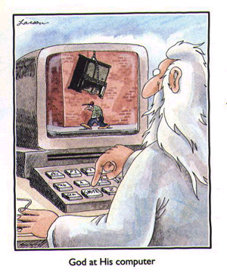
Creation: Peace or Conflict?
Monisms
- Determinism – God = all powerful and good, does everything – Creation suffers for some higher purpose.
- Deism – limits God’s ongoing ‘control’ – Creation suffers for some higher purpose = the production of free persons.
Doctrines of evil/sin cannot be composed on their own, independent of larger theological matters.
- find it difficult to retain any sense of the conflictual nature of in the world.
- Evil is ‘written into’ their ‘systems’.
- In a sense, then, it is justified and rendered something less than ‘evil’

Dualisms
- Gnosticism –
- Manichaeism –
Evil is conflictual, but evil here
- is in perpetual conflict with the Good.

- is externalised and substantialised:
  - this externalisation can in turn make evil/sin a quality possessed
  - turn the attention away from ourselves (therapy culture, culture of blame)
  - fail to deal with what makes evil/sin

There is also an opposite danger in Internalist Approaches:
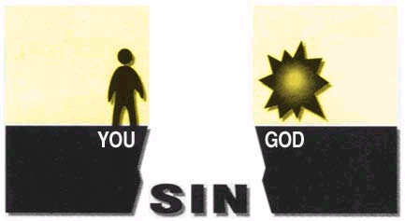
“Sin is like a dark smudge on the soul. Each smudge (sin) blocks God's grace from reaching your heart.” [troubledtimes.saint-mike.org/ Chapter2.html]
- But this individualises evil = sin
- turn the attention to ourselves (therapy culture, culture of guilt)
- fail to deal with what makes evil/sin

