The Ongoing
American Farm Crisis
a socialist perspective
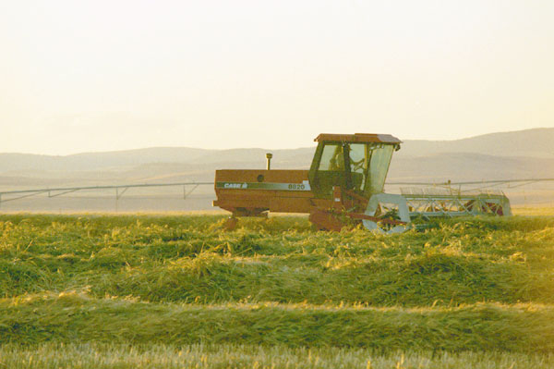
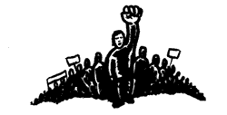

Socialist Action
P.O. Box 16853, Duluth MN 55816 or 298 Valencia St., San Francisco 94103
www.socialistaction.org or www.geocities.com/mnsocialist/farmers.html

labor donated

The Ongoing National Farm Crisis

By Adam Ritscher
The roots of the current farm crisis reach back into the 1970s. At that time farmers were rushing to buy and rent more land and machinery to take advantage of a huge increase in the export of agricultural products overseas being orchestrated by the U.S. government. Banks were anxious to lend money, and to most farmers it seemed as if the prosperity would go on forever.
It didn't, of course, and when the bubble burst in the late 1970s and early '80s, the effects it would have on American farmers would be devastating. Many of the foreign countries importing U.S. produce had gone bankrupt, and at the same time the value of the U.S. dollar rose, making American goods more expensive in foreign markets in relation to competitors such as Canada, Argentina, and France.
Faced with a collapse in prices for their crops and livestock, farmers were unable to pay back the loans they owed to the banks. While farmers owed nearly $50 billion to the banks in 1970, by 1985 farmers were $215 billion in debt, the interest on which was a staggering $20 billion a year.
Consequently, a wave of farm foreclosures swept the country like a deadly plague, and by the mid-1980s a thousand farmers were being forced off the land a week! Families who had worked the land for generations were forced to turn their farms over to the banks and moneylenders, sometimes doing so only at the gunpoint of the county sheriff's shotgun.
Many farmers responded to this crisis by coming together in militant protest. Militant tactics from the farm struggles of the l930s were resurrected to combat the foreclosures. Among them was the "penny auction," where farmers would gather at the auction of a foreclosed farm and "persuade" anyone from making any bids more than a few cents, and then returning the land and machinery to the foreclosed-upon farmer.
A new tactic employed by militant farmers was that of the tractorcade. In many states, farmers decided to converge upon their state capitols on their tractors and drive home in a dramatic way their desperate need for relief.
In Minnesota, for instance, 17,000 tractors drove to the steps of the state capitol building demanding action. And in 1979, tens of thousands of farmers from across the country converged upon Washington, D.C. Peanut plantation millionaire Jimmy Carter dismissed the protesting farmers as simply being "greedy."
Numerous militant farm organizations began to spring up as a result of these protests, such as Groundswell, the Family Farmer Survival Association, and the American Agriculture Movement.
In addition, under the pressure of small farmers, many of the traditional farm organizations, such as the National Farmers Union, the National Farmers Organization, and the Farm Bureaus Federation began to raise their voices in support of government relief to farmers.
Betrayed by political "friends"
What followed this wave of protests and militancy, though, can probably be best described as a wave of betrayal. The main betrayers, of course, were the Democrat and Republican politicians-who had held the farmers up as a model of "family values" in their election campaign speeches-and turned their back on the farmers as soon as they felt they could get away with it.
The farm bills and programs they enacted did little for the family farmers who needed it, and instead ended up helping the agribusiness giants. Instead of a moratorium on farm foreclosures or real economic aid, they handed out tax breaks and welfare to the likes of Cargill, Archer-Daniel-Midlands, and Purina.
One absurd program these politicians did enact was to provide farmers with subsidies or tax breaks if they took a certain number of acres out of production. The idea was to reduce the amount of crops harvested, and force up the prices.
This was at a time when thousands were dying of starvation around the world, and when even in America there were thousands of children with not enough food on their plates. Nothing illustrates the irrationality of capitalism more than paying bankrupt farmers not to raise food in a world where people are starving.
But in addition to the politicians, there stood in the ranks of the betrayers many of the leaders of the farm organizations. Although there were some notable exceptions, most of these leaders came to their members in tailored suits claiming that farmers needed to set up their own lobbying groups in order to get what they needed from Washington.
They then exaggerated the benefits of whatever farm legislation was passed to make it look like their members were getting something for all the money they were paying in dues. In reality, a couple of tailored suits were all that the money bought.
The decline in farmer militancy that resulted from this misleadership was seized upon by the ruling class and their media as proof that the farm crisis had ended.
And although prices did inch up a little here and there, and the number of farm foreclosures fell as the weakest of farmers were pushed off the land, this represented simply a slight decrease in the severity of the crisis, not its end.
Farmer debt still totaled up to almost $200 billion, and this figure has continued up to today, just slightly less than its mid-1980s peak. Also the number of farmers overall has continued to fall; despite having hit an all time low in the mid-1980s of 2.1 million, today the number is even lower, at 1.9 million.
Rise of factory farms
Aggravating and contributing to this situation is the continued rise of factory farms. Even though the vast majority of farms in America are still small family farms, in certain sectors of agriculture-such as pineapples, strawberries, grapes, exotic fruits, poultry, pork and vegetables-factory farms are becoming the norm.
Where I come from, for instance, in western Wisconsin, poultry used to be a common source of supplementary income and food for most farmers. Today though, massive chicken sheds that have price tags of $200,000 and that turn out up to 60,000 chickens a month have completely taken poultry out of the hands of the small farmer.
Another serious problem is that even when prices do rise somewhat, as they did in the early and mid-1990s at times, it's often offset by the continuing rise of operating and maintenance costs. The giant farm implement manufacturers, which in the 1970s were caught engaging in price fixing deals, have now eliminated the risk of getting caught by simply merging.
While once upon a time there were dozens of farm equipment manufacturers, today you can count them on your hand and have a few fingers left over. The result is that a new, top of the line, eight-wheel tractor now costs as much as a Rolls Royce!
Since no family farmers can afford such prices, they are forced to try to keep running machinery that is decades old. In my county it's quite common for farmers to be using equipment that is 30-35 years old. Growing up on the farm, I remember spending as much time repairing machinery as using it.
In the 1990s farmers have been responding to the ongoing crisis in an uneven and contradictory way. Again, misleadership plays a big role here. Additional millions are being tossed into the lobbying shredder by the bureaucrats sitting on top of the farm organizations. On the few occasions a protest has been called by these bureaucrats, they use every excuse possible to either cancel them or direct them in a worthless direction, such as campaigning for left-sounding Democrats.
The American Agriculture Movement (AAM), which during the late 1970s and early '80s had been the most militant of the farm organizations, has been both marginalized by the more traditional and conservative groups, and has been wrung free of many of the militant farmers who once proudly filled its ranks.
While in the 1980s the AAM took the initiative of founding the North American Farm Alliance and the North American Farmer newspaper to link together the struggles of farmers on both sides of the border, today it organizes demonstrations on the Canadian border demanding government policies that will keep Canadian grain and beef off the U.S. market.
Frustration with these farm organizations has led some desperate farmers to look to the dangerous right-wing demagogy of the likes of Lyndon LaRouche and Pat Buchanan. In the last presidential elections, for instance, Buchanan won the Republican primary in Iowa with the vote of thousands of angry and confused farmers. Thus we see the desperate need for an organized socialist alternative to which farmers can turn.
The fact that family farmers still run 99 percent of the farms, are the largest owners of land in this country, and still produce the majority of agricultural produce, makes them an important ally of the labor movement.
What is needed today is a strong alliance between farmers and labor that is independent of the misleading Democrats and Republicans, and that is equipped with an internationalist perspective recognizing the need for solidarity with all working people, regardless of borders.
Such a force can and will wrest control of this country from the hands of big business, and put it in the hands of those who through their sweat and labor truly deserve it.

