Ninety percent of all fish are bony fish, which are fish that have a skeleton made of bone. Bony fish include swordfish, tuna, flounder and salmon.
1st dorsal fin

2nd dorsal fin
Lateral line
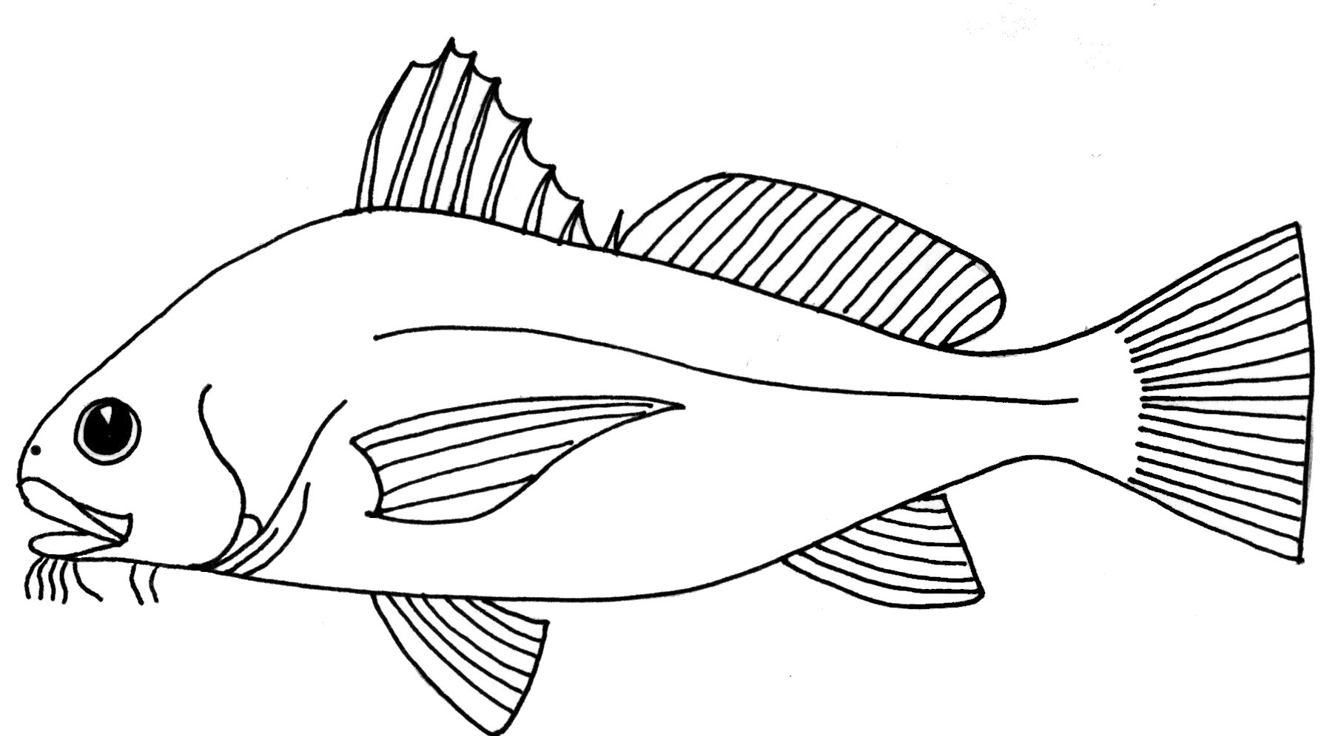
mouth
Anal fin
eye
nostril
operculum
Caudal fin
Pectoral fin
Pelvic fin

The gill cover, called an operculum, protects the gills. Water passes through the mouth and over the gills of the fish. As the water passes over the gills, oxygen enters the fish’s bloodstream and is carried throughout its body. The nostrils of a bony fish are used for smelling and not for breathing.
Bony fish have fins that are used for swimming, stability, and steering. The dorsal and anal fins keep the fish level in the water and keep it from rolling. The caudal fin helps propel the fish forward and steer. The pelvic fins help keep the fish level in the water. The pectoral fins help the fish steer and brake.
The lateral line is a sense organ that helps the fish detect vibrations in the water.

