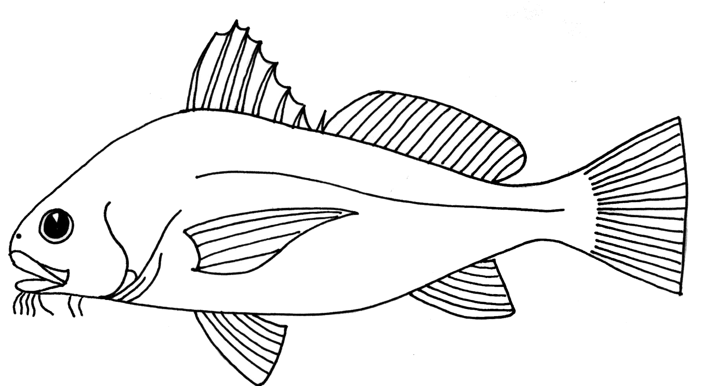

atomy of Bony Fish

1st dorsal fin
2nd dorsal fin
Lateral line

eye
atomy of Bony Fish
nostril
Caudal fin
mouth

Anal fin
Pectoral fin
operculum

Pelvic fin

