Youth 4 Socialist Action Membership Handbook
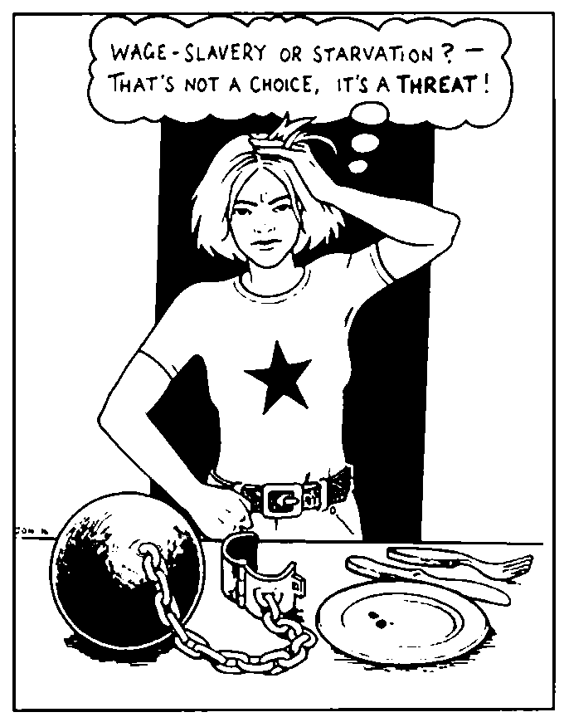
An introduction to YSA, our group’s history, our politics and what you can do to help us make a difference!

YSA National Office: P.O. Box 16853, Duluth MN 55816 - mnsocialist@yahoo.com

Youth for Socialist Action’s Mission Statement

Welcome to Youth for Socialist Action! We're a nation-wide multi-racial network of young workers, students, feminists and activists committed to the fight for socialism.

We are an organization confident that we can make a difference. We are determined to build a world where people come before profits, and that is free of exploitation, racism, sexism and homophobia. And while as socialists we are in the minority today, we are optimistic that workers, young people, and the oppressed can and will, in the end, create a better world.

Our optimism is based on these two facts:

1. Capitalism has proven itself to be unable and unwilling to provide for the most basic needs of the majority of people. It is destroying the planet, pitting people against one another, and robbing us of a future where we can grow together in a world free from poverty and alienation.

2. Young people, workers and oppressed nationalities all over the world are fighting back, and in that fight back we are learning, getting better organized, and coming together. And in that there is hope!

We seek to build a revolutionary youth movement that can effectively fight on behalf of youth and working people across North America, and link the politics of socialism to the struggles of all progressive social movements. We try to be the best builders of social movements which resist the attacks of capitalism. We seek to unite different groups of people who are fighting back, show how all of our struggles are connected, and build a core of revolutionaries that can provide direction in these struggles.

Concretely, we fight for broad based united front coalitions with principled, but broad appealing demands. We advocate mass action tactics – our strength is in our numbers! We fight to keep social movements independent of the Democratic and Republican parties, and all pro-capitalist third parties. We fight for autonomous movements of the specially oppressed (African-American, women’s, GLBT, etc.) so that these movements can develop their own demands and their own leaders. We also though fight to connect different movements – labor to the women’s movement, etc – because an injury to one is an injury to all! We also fight to bring an internationalist perspective to the social movements. And through all of this we seek to bring together serious activists who wish to learn the lessons of past victories and defeats, to take up the task of being revolutionaries who can be the vanguard of the fight for a better world!
Towards those ends we organize ourselves into chapters based on campuses, workplaces and communities. Through these chapters we get involved in the various struggles for a better world, as well as come together to educate ourselves and learn how to be effective activists. We seek to increase our effectiveness by acting as a collective unit.

Membership in YSA is open to any young person in the U.S. who agrees with our 10 Point Program, pays $10 annual dues, and is willing to make a commitment in time & energy to YSA.
So what are you waiting for? Read up, plug in, join up, and let’s do our part to make a revolution!


YSA Membership Requirements:

Youth for Socialist Action is open to any young person who is A.) in agreement with our 10 Point Program (see below), B.) commits to trying to be an active participant within the organization, and C.) who pays dues ($10 a year – though exceptions can be made for unemployed comrades).

YSA’s 10 Point Program

[1] We stand for workers' democracy & socialism. We are active partisans in the class struggle!
[2] We fight against racism in all its forms. We are supporters of Black liberation, and defend the right of self-determination for oppressed nationalities.
[3] We are opposed to any and all discrimination based on gender or sexual orientation. We support equal rights for all!
[4] We fight to protect the environment from the ravages of capitalism.
[5] We fight to empower young people, on campus, in the community, and in the workplace.
[6] We fight against police brutality, and any measures by the state to take away or restrict our democratic rights.
[7] We stand for free quality education for all, from pre-school to graduate school.
[8] We denounce imperialism, and oppose all U.S. foreign interventions, regardless of the given justification.
[9] We denounce the U.S. embargo against Cuba, and stand in solidarity with the Cuban people & their revolution.
[10] We advocate independent working class political action. Break from pro-business politics!

An Active Membership

We understand that comrades have busy lives, but it also must be understood that without the active participation of our membership, YSA is nothing but a list of names. That is why we strongly urge all YSA members to strive to attend all YSA meetings, endorsed demonstrations and to stay in regular contact with their chapter’s Organizer (or if you’re an at-large member, the National Office) so that you help with the day to day work of YSA such as leafleting, distributing Socialist Action newspaper, planning meetings and protests and other work related to our campaigns. If comrades anticipate a busier than usual work load, or semester at school, or if they feel they just need to take a couple of weeks off, they should contact their chapter Organizer.

How YSA is Financed

Youth for Socialist Action is not financed by grants or some deep pocketed individuals. All of the money for leaflets, postage, travel and other operating and organizing expenses comes from contributions of our members. It is for that reason that we charge $10 a year dues.

Comrades should bear in mind though that the money we collect from membership dues only goes a small way in covering our expenses. We urge members to consider giving regular donations, and to at the very least set aside “Change 4 Change” cans to collect their spare change to use as a donation. Donations of stamps and envelopes are also appreciated!

What You Can Do:

So, you’ve taken plunge and joined YSA. But now what? Well, as our name suggests Youth for Socialist Action is about two things – socialism and activism. Below is a list of things to get you on your way to becoming a revolutionary!

Educate Yourself!

YSA encourages its members to learn about the history of the socialist & workers movement, what is stands for and why. For starters, we urge all of our members to read the essays in this Membership Handbook. There are additional essays in the YSA Organizing Handbook, which is available from the National Office for $1. But we also put out a variety of educational brochures, and a list of recommended books that you can get at your local bookstore or library.

Xeroxed Essays Available From the YSA National Office:

1. “What Socialists Stand For” by Gordon Shultz (essay)
2. “America’s Road to Socialism” by James Cannon (essay)
3. “How to Make a Revolution” by Peter Camejo (essay)

Free YSA Brochures:

1. What is Socialism; 2. The Case of Mumia Abu-Jamal; 3. Marxism vs. Anarchism; 4. YSA Membership Brochures; 5. The Fight for the Environment; 6. Sexism & Advertising; 7. What is Dialectical Materialism; 8. End the Occupation of Iraq; 9. End the Death Penalty …

Recommended Books (available from libraries & bookstores):

1. “In Dubious Battle” by John Steinbeck
2. “The Iron Heel” by Jack London
3. “The Jungle” by Upton Sinclair
4. “The Autobiography of Malcolm X” by Alex Hailey
5. “Stone Butch Blues” by Leslie Feinberg
6. “Communist Manifesto” by Marx & Engels
7. “State & Revolution” by V.I. Lenin
8. “Transitional Program” by Leon Trotsky
9. “Feminism & Socialism” by Linda Jenness
10. “History of American Trotskyism” by James Cannon

Get Involved!

Educating yourself is one part of becoming a revolutionary, getting involved is the other. Get involved with your local YSA chapter to plug into the local anti-war, anti-racist, women’s rights, GLBT, labor and other social movements.

YSA chapters are where our members come together to plan activities as a group, and to make sure that as a group we are making our contribution to the fight back against capitalism, be it through coalition building, or recruiting new people to the revolutionary movement. Volunteer to write for Socialist Action newspaper; be the YSA representative in a local activist coalition; post up fliers for protests and YSA events; help organize a forum or study group. Working together there is no limit to what we can do!
What is Socialism?

What is socialism? If you read something like the Wall Street Journal, you’d be told that socialism is an evil idea where an all-powerful government forces everyone to wear identical looking black pajamas and live the life of drone ants. They say that it’s against human nature, that its been tried and it has failed, and that it negates individuality and creativity.
But if it’s as bad an idea as the Wall Street Journal says it is, why does it continue to motivate millions of oppressed people around the world? What do socialists themselves define socialism as?
Socialism is about hope and resistance - which is why the Wall Street Journal feels so threatened by it! Socialist ideas continue to exist and to inspire millions because it holds that the world we live in can be made better if we simply have the courage and self-respect to stand up and fight for it. Socialism says that if we can liberate humanity from the control of the wealthy minority that now owns it and runs it in its own narrow interests, we can all live a life free from oppression, exploitation and alienation.
We see the world as one divided into class. And while capitalism oppresses people in a variety of ways in addition to class, such as race, sex, sexuality and age, we base our struggle for change on the struggle of the working class because it's the only social force with the real interest and ability to abolish ALL forms of oppression. The working class, because it lives by selling its labor, can, unlike any other group, stop the capitalists dead in their tracks. By going on strike for example, goods are not produced and the bosses economy comes to a halt. Workers have the power to not only hit the capitalists where it really hurts, but the power to bring this whole wretched capitalist system down.
But lets get back to the basic definition of socialism. The root word of socialism is the world ‘social’ – and that’s the most important thing to remember about socialism. Basically socialism is the belief that what is socially produced should be socially owned. In other words, if hundreds of people come together to produce a factory, it shouldn’t then become the sole property of one person. Socialists hold that production should be based on human need, not profit. Instead of large factories and offices being run by individual capitalists whose sole interest is profit, they should be democratically controlled by the workers. Socialism is about genuine democracy.
Now of course our rulers also say they support democracy. Yet in our society, most people have only a minimal say in what goes on. We elect a new government every four years, but in between we have almost no control over what it does. More importantly, the most significant decisions in society are made by unelected people. The heads of big corporations decide what products are produced, who they will employ and what those jobs will be. Socialists are for a new form of democracy, far more reaching than anything possible under capitalism. We are for a society in which ordinary people control every aspect of life - a democracy that's economic as well as political.
Socialism also means co-operation rather than endless competition. Today humanity faces huge problems like the spread of AIDs and destruction of the environment that threatens the whole planet. Instead of different companies hiding their research in the name of 'business secrets' or fighting each other for market share, socialists believe that we should pool our resources to solve problems.
And how are we going to get socialism? We’re going to have to fight for it. The Wall Street Journal’s bashing of socialism is just the tip of the iceberg of what the powers-that-be can and will do to prevent this redistribution of wealth and power. That’s why socialists call for revolution – an overthrow of the parasitic minority by the empowered majority. And don’t think that revolution is a far-fetched idea. While it will indeed be an uphill struggle, history shows that revolutions are inevitable. The question is whether they will succeed, and that depends on the level of political clarity and organization those who make the revolution have. And that’s why we exist. We believe that Socialist Action and Youth for Socialist Action can, and will, make a useful contribution to the building of a successful revolutionary movement. That’s why our goal as socialists today is to build a revolutionary organization that can participate in mass struggles, draw lessons from past victories and defeats and convince the working class of the way forward to socialism. Such an organization cannot be created from on high - it needs to be built out of the conflicts taking place today. That's what we are attempting to do. We meet regularly to discuss our ideas and work out how they can be tested in practice - in our workplaces, unions, campuses and social movements. We invite you to join us in this movement for the emancipation of humanity!

History of the Revolutionary Socialist Youth Movement

The long and colorful history of the socialist youth movement in the United States goes back to the very beginning of socialism in America. Soon after founding the Socialist Party of America in 1901 by Eugene V. Debs, its youth group, the Young Peoples Socialist League, was founded. Together with SP affiliated college student organizations, the YPSL grew to incorporate thousands of young and militant Americans in the tumultuous pre-World War I years in this country.
With the outbreak of World War I though, and the ensuing crack down on all radical groups by President Wilson, the YPSL was subject to harassment and to numerous violations of its members constitutional rights by the government, and the patriotic mobs that that it whipped up.
In the midst of this anti-radical persecution, which continued well into the 1920s, the 1917 Russian Revolution led by V.I. Lenin and Leon Trotsky grabbed the attention of every radical in America, young & old.
A huge debate broke within the ranks of the Socialist Party and the Young Peoples Socialist League over what attitude to take to the new fledgling workers’ state in Russia. The revolutionary spirited elements parted ways with the conservation wing of the Socialist Party, and launched the American Communist Party in 1919. And again, shortly afterwards, the students and young workers attracted to the new party’s banner came together to found a youth group, the Young Communist League.
However, the Young Communist League and the CP were born in troubled times. Continued government persecution, now including forced deportation of foreign born radicals, forced the young movement underground. At the same time, intense pressures from imperialist countries, and the overwhelming destruction and backwardness which faced the Bolsheviks, was resulting in a bureaucratic degeneration of the revolution in Russia. Led by the ruthless Joseph Stalin, a self-serving bureaucracy has usurped power in Russia following the death of Lenin in 1924. It quickly moved to quench dissent, and abandoned the idea of world revolution, contenting themselves instead with preserving their new power and privilege.
In America, the leadership of the Communist Party went along with the changes taking place in Russia. Following Stalin’s example, the leadership of the CP sought to end any dissent, demanding unquestioning loyalty to whatever policy the leadership passed down.
A small group of Communist Party members around James P. Cannon however, who were still committed to democratic ideas of the Russian Revolution, challenged the CP leadership. In 1928 they were expelled. Immediately afterwards they launched a newspaper, the Militant, and a new organization, the Communist League of America. Despite being isolated and attacked by the now Stalinist Communist Party, Cannon and the CLA fought to defend revolutionary politics, and as a result the CLA grew in both members and influence. In the early 1930s it launched a youth group, the Spartacus Youth League.
In the same manner as its parent organization, members of the SYL and their newspaper, the Young Spartacus, sought to win the hearts and minds of students and young workers in competition with the Young Communist League and the Young Peoples Socialist League.
In 1936, both the Communist League of America and the Spartacus Youth League dissolved and re-entered the Socialist Party and the Young Peoples Socialist League. This was in response to a dramatic growth of the Socialist Party, and the Socialist Party leadership’s call for a party that would be home to all socialists. Taking into the SP though their revolutionary politics, the Trotskyists were attacked by the conservative leadership of the SP, who now worried they may loose control of the SP and the YPSL.
After enduring numerous organizational maneuvers and attempts at censorship by the SP leadership, the Trotskyists left the Socialist Party, and in 1938 founded the Socialist Workers Party. Hundreds of workers left the SP with them, as did all the youth. The Young Peoples Socialist League now became the youth group of the new Socialist Workers Party!
By this time however the winds of World War II were beginning to blow, and once again the left came under attack by the government and its henchmen. The SWP was evicted from its position of power in the Midwest Teamsters union, and its leadership arrested and put on trial for opposing U.S. entry into the war.
Buckling to the intense pressure upon the left to abandon any defense of the Russian Revolution, including the gains which continued to survive despite the bureaucracy, a wing of the SWP under Max Shactman split the party, taking most of the YPSL with it. The remainder of the SWP continued to defend revolutionary politics throughout the war, as well as the McCarthyite 1950s, but it was unable to maintain a youth group.
The late 1950s and early 1960s saw the beginnings of a significant radicalization of young people. Fueled by the inspiration provided by the civil rights movement in the United States and the Cuban Revolution of 1959, a growing number of young people began to look to radical answers to the injustices they saw around them. The Socialist Workers Party responded to this radicalization by reaching out to these young people, and launching a new youth group, the Young Socialist Alliance.
Throwing itself into the growing movement against the unjust war in Vietnam, the YSA quickly grew to become one of the largest and most effective radical youth groups in America. Despite competition from various ultra-left, Maoist and Stalinist groups, the Young Socialist Alliance, through coalitions such as the Student Mobilization Committees, was able to build a mass youth movement against the war in Vietnam around the slogan of “Bring the Troops Home Now!” This was in contrast to the slogans of “Drive the G.I.s Into the Sea” and “Tune In, Tune Out” of its less serious competitors.
The result of the YSA’s and the SWP’s role in the anti-war movement, a majority of people were swung to oppose their government’s policy in Southeast Asia, and to no small degree, end the war.
The YSA entered the 1970s with a strong base on all of the major U.S. campuses, and the respect of student activists everywhere. Its newspaper, the Young Socialist, had a readership in the tens of thousands. Armed with the experience it had gained in the anti-war movement, the YSA was able to play a significant role in the struggles around racism and continued segregation in the schools that unfolded in the late 1970s.
The size and valuable experience of the YSA however was largely destroyed in the early 1980s when a new leadership in the Socialist Workers Party began to abandon the politics it had stood by in the past, and engaged In a series of twists and turns. Members of the YSA were ordered to quit school and to go and get jobs in industry. In response to this, and the bizarre political lines being passed down by the SWP leadership, many youth in the YSA dropped out, and were lost from the revolutionary movement.
Just as a group of sincere revolutionaries had resisted the degeneration of the Communist Party in the 1920s, so too was the case with the SWP. These dissenters, like James Cannon, were also expelled, and forced to form a new organization. The name of the new group was Socialist Action, the party that Youth for Socialist Action is tied to.

Being born in the conservative 1980s however, Socialist Action found it hard to find young people interested in revolutionary politics. Several efforts were made to reach out to students on the campuses, and throughout the 1980s and early 1990s several “Students for Socialist Action” clubs were formed in places like San Francisco and Cincinnati. Unfortunately it wasn’t until the mid and late 1990s that Socialist Action was able to gather around it enough young revolutionaries to begin thinking about launching a youth group.
The organization that was created by these initial young people was Youth for Socialist Action. Today, the new YSA is able to stand with the confidence and wisdom inherited from an almost century old revolutionary youth tradition behind it. Drawing from the lessons of the early Young Peoples Socialist League, Young Communist League, Spartacus Youth League and the Young Socialist Alliance, Youth for Socialist Action is proudly marching into the twenty-first century with the banner of revolutionary socialism held high!



